TASK 1: DNA/Protein Sequence Analysis
TITLE: BLAST Analysis to Identify Homologous Sequences.
NCBI – BLAST (Basic Local Alignment Search Tool) works on Smith-Waterman algorithm to find the region of similarity between biological sequences (Nucleotides or proteins). This program compares the nucleotide or protein sequences to the sequence databases and calculates the statistical significance of homology similarity among the different organisms.
As it uses local alignment algorithm, it identifies and aligns only the highest-scoring, most similar subsequences within two sequences, making it suitable for comparing dissimilar sequences or finding conserved regions within longer sequences.
Objective
The objective of this work was to be analyse the nucleotide/protein sequence to identify homologous sequences in other organisms and analyze similarity, identity, and alignment scores by performing BLAST.
Methodology
- The query sequence (ACCESSION NO. XNZ85062.1) was taken from the NCBI protein database.
- The sequence of RecA, partial [Escherichia coli] was selected:
>XNZ85062.1 RecA, partial [Escherichia coli] ARKLGVDIDNLLCSQPDTGEQALEICDALARSGAVDVIVVDSVAALTPKAEIEGEIGDSHMGLAARMMSQAMRKLAGNLKQSNTLLIFINQIRMKIGVMFGNPETTTGGNALKFYASVRLDIRRIGAVKEGENVVGSETRVKVVKNKIAAPFKQAEFQILYGEGINFYG
- The sequence was copied in the FASTA format.
- Then visited https://blast.ncbi.nlm.nih.gov/ ( NCBI-BLAST Tool).
- Then BLASTp was selected as my query was protein.
- The database selection and parameters were kept at default settings.
- The query sequence was submitted to the BLAST server.
- The program compared the query sequence with sequences in the selected database.
- Then click on the BLAST to get results.
Results
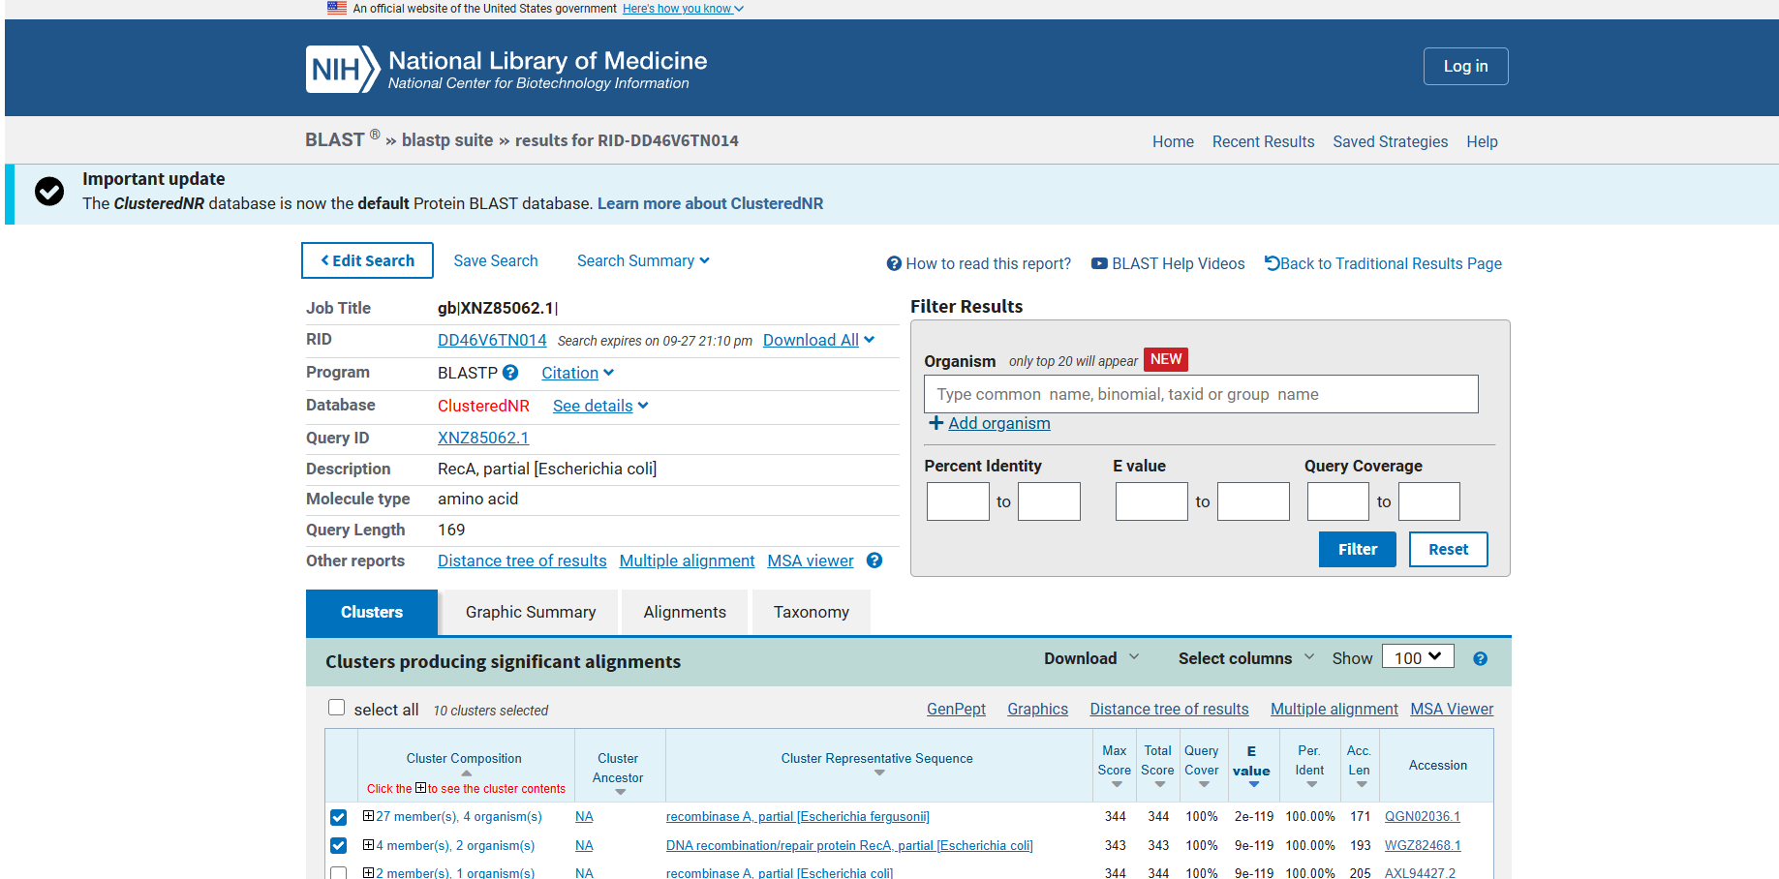
Fig1: Showing details of the query sequence (RecA partial sequence from Escherichia coli) i.e. The query length is 169 amino acids, and the search was performed against the ClusteredNR database using the BLASTP program.

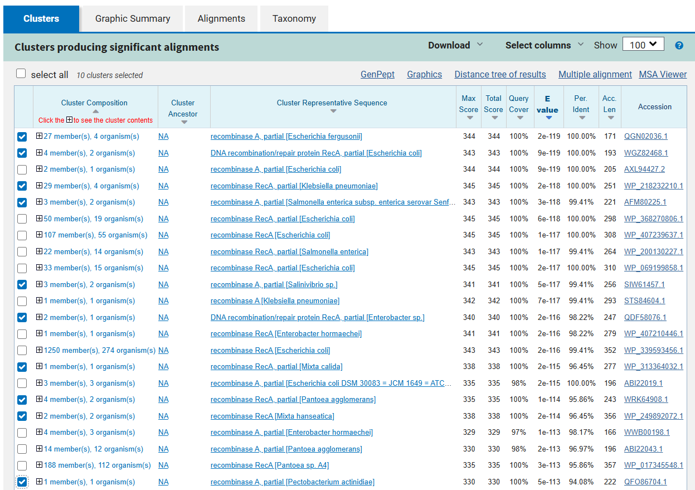
Fig2: Showing significant alignments with details on sequence similarity, E-values, and accession numbers.

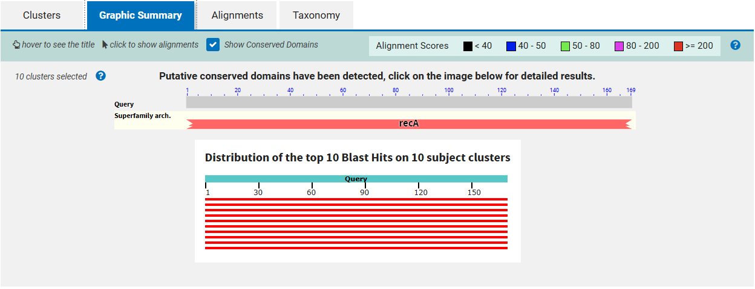
Fig3: Showing graphical summary of conserved domain architecture of the query sequence. The RecA superfamily domain is detected, and alignment scores for the 10 BLAST hits are distributed across the full query length (169 amino acids), indicating strong conservation.
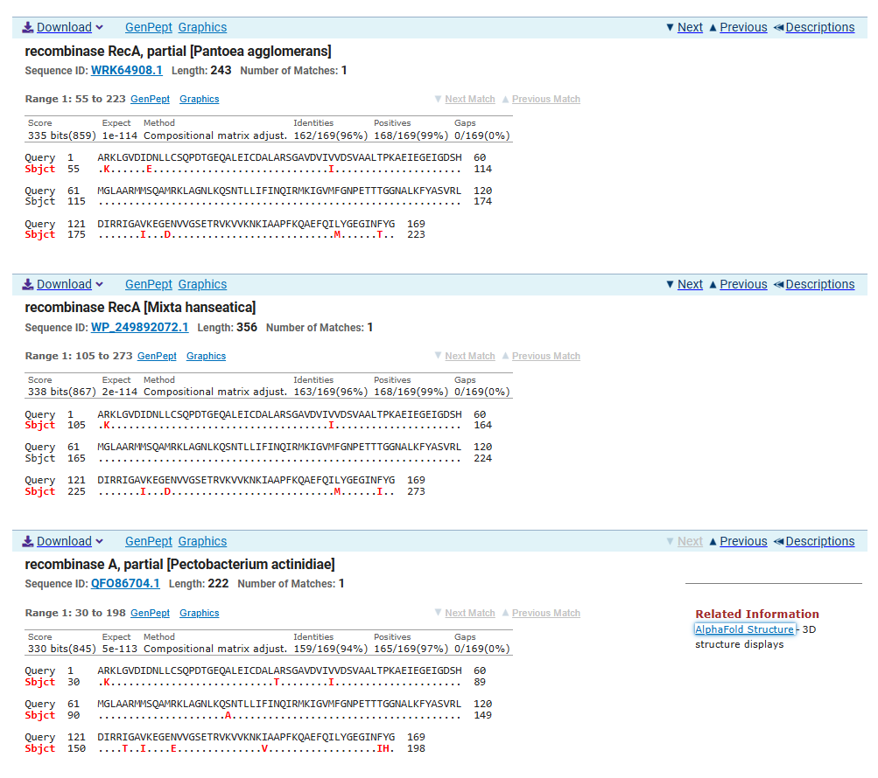
Fig4: Shows the comparative BLAST alignment (pairwise with dots for identities) results for RecA protein sequences from three bacterial species— Pantoea agglomerans, Mtzia hansenii, and Pectobacterium actinidiae.

Report Analysis
Low E- value and high similarity indicated the query protein was evolutionarily conserved and may shared a common ancestor with homologs in other species. Insertions, deletions, or mutations that may affect protein structure, adaptation, or pathogenicity which are highlighted by differences in alignment length or % identity.
Also, BLAST predicted the role of the query protein If the sequence matches a protein with known function. The BLAST result shows evolutionary relationships among species which indicates the sequence is conserved across species.
The results were obtained on the new update of the NCBI – BLAST, which is ClusteredNR, as of August 2025, it would be the default protein BLAST database. It is a reduced-redundancy version of the standard protein nr database, in which sequences are grouped (clustered) if they are ≥ 90% identical over ≥ 90% of their length.
So out of one hundred results of clusters I choose ten clusters (Pantoea agglomerans, Mixta hanseatica, Mixta calida, Pectobacterium actinidiae, Escherichia coli, Salmonella enterica, Enterobacter sp., Escherichia fergusonii, Salinivibrio sp., Klebsiella pneumoniae).
Organism | Accession No. | Score | E-value | % Identity | Query coverage | Alignment length
Escherichia fergusonii | QGN02036.1 | 344 | 2e-66 | 100.00% | 100% | 171
Escherichia coli | WGZ82468.1 | 343 | 9e-119 | 100.00% | 100% | 193
Klebsiella pneumoniae | WP_218232210.1 | 345 | 2e-118 | 100.00% |  | 251
Salmonella enterica | AFM80225.1 | 343 | 1e-117 | 99.41% | 100% | 264
Salinivibrio sp. | SIW61457.1 | 341 | 5e-117 | 99.41% |  | 256
Enterobacter sp. | QDF58076.1 | 341 | 2e-116 | 98.22% | 100% | 247
Pantoea agglomerans | WRK64908.1 | 335 | 2e-113 | 95.86% | 98% | 196
Mixta hanseatica | WP_249892072.1 | 338 | 2e-114 | 96.45% | 100% | 356
Mixta calida | WP_313364032.1 | 338 | 1e-112 | 96.45% | 100% | 277
Pectobacterium actinidiae | QFO86704.1 | 330 | 5e-113 | 95.08% | 100% | 222
Table 1: Shows the description of percentage identity, E-value, alignment score of selected species
The BLAST analysis of the query protein (. XNZ85062.1) showed the high degree of sequence conservation among members of the family Enterobacteriaceae and related genera. The strong homology similarity was observed with Escherichia fergusonii (Accession No. QGN02036.1), Escherichia coli (Accession No. WGZ82468.1), and Klebsiella pneumoniae (WP 218232210.1), these three showing 100% identity and 100% query coverage, with the alignment length 179 and 193 amino acids, respectively. This showed that the query sequence was either identical to or highly homologous with proteins encoded by these species.
It also demonstrated remarkably high similarity, ranging from 99.4 - 98.22 identity among closely related organisms, including Salmonella enterica (AFM80225.1), Salinivibrio sp. (SIW61457.1), and Enterobacter sp. (QDF58076.1).
The variation in alignment length suggested that the core functional domains were conserved, structural variations such as insertions or deletions may exist among varied species. These variations were observed among the Pantoea agglomerans, Mixta hanseatica, Mixta calida, and Pectobacterium actinidiae, showing sequence identities between 95.08–96.45%, with alignment lengths varying from 196 to 356 amino acids.
The remarkably low E-values (range from 2e-66 to 5e-113) suggested the observed similarities were statistically significant and not due to chance. These data revealed that the query protein was highly conserved throughout Enterobacteriaceae, with remarkable evolutionary conservation extending to related bacterial taxa.
Overall, the results showed that the query protein was highly conserved and plays an essential biological role in DNA repair, homologous recombination across diverse bacterial taxa.

